Synchronization of Fireflies

Master Program “Complex Systems and Networks”

*Supervisor: Antoniou Ioannis*

*Georgoulis Filippos*

*Kofterou Maria*

*Foudouli Anastasia*

*“… But at a deeper level, there is a connection, one that transcends the details of any particular mechanism. That connection is mathematics. AII the examples are variations on the same mathematical theme: self-organization, the spontaneous emergence of order out of chaos…”*

*Steven H. Strogatz*

Σωτήριον έτος 2018

Contents

Introduction 3

The Fireflies’ Synchronization 4

Species Diversity 5

Types of Synchronization 6

Coupled-Oscillators Synchronization 8

Kuramoto Model (1975) 8

Charlie S. Peskin (1975) 11

Mirollo and Strogatz (1990) 12

Outline of the Poof 12

Model of N Pulse-Coupling Oscillators 13

A simplified version of Mirollo and Strogatz model 15

Model’s discussion 15

B. Ermentrout (1991) 16

Adaptive Frequency Model for Collective Behavior 16

Model’s Discussion 19

Synchronization in Small-Words 20

Implementation 30

1st Model 30

2nd Model 31

3rd Model 31

4rth Model 31

Comparison 32

Bibliography 33

# Introduction

This essay examines the effect of flashing synchronization in firefly groups. The basic approach, the traditional one, examines the phenomenon as a system of coupled oscillators. A brief introduction to the history and behavior of the problem is given, in an effort to create an historical skeleton of all the contributors, those who studied the biological effect, these that developed the mathematical background of coupled oscillation problem and the ones that matched these two together. The basic models developed; Kuramoto, Peskin, Mirollo-Strogatz and Ermentrout will be presented and discussed.

In the second part, fireflies’ system is considered as a small-world example; the phenomenon of synchronization will be approached by this perspective. The specific characteristics of small-worlds that are linked to synchronization are discussed, numerous examples are presented, and the phenomenon of synchronization as it applies specifically on small-worlds is examined.

Finally, several implementations of simplified models we developed in Python with visualization of the phenomenon of fireflies’ flashing synchronization is presented and discussed.

# The Fireflies’ Synchronization

Fireflies belong to the beetles’ family and there have been found more than 2000 species worldwide. The phenomenon of synchronization stands for a certain behavior showed among several species of fireflies, a tendency to synchronize their flashings when formed in groups. That is, to gradually adapt their flashing frequencies accordingly until there is only a common flashing time for the whole group. And more remarkably yet, fireflies not only flash in unison but they flash in a rhythm, in a constant tempo.(S H Strogatz, 2012)

After several decades of this phenomenon being either declined or linked to meta-physical explanations, it was John Buck and his colloquies that made the first well based scientific investigation of the phenomenon and set a first light on why and how synchronization occurs. (Buck & Buck, 1966). First of all, it is the males that tend to synchronize, which later biological discoveries explained by linking flashing to mating goals, as males rove around looking for sedentary females or flash in unison to draw their attention. Flashing is also interrelated to a code of communication, similar to Mors signal. Moreover, there is no apparent leader or conductor, entrainment is spontaneous, fact that is actually possible as Mirollo and Storatz proved a couple decades later, as well as, there is no global communications- each firefly has a limited receptor radius for flashing signals. Finally, synchronization is emerged as swarms change dynamically and thousands of insects can be involved.

Moving from empirical examination of the phenomenon to laboratory experiments with artificial lighting in several species’ individual fireflies, Buck and his colleagues in 1981 where the first to conceive of fireflies’ flashing synchronization as a coupled-oscillator synchronization model(Buck, 1988). For their main specie f interest, P.Cribellata, they opted for a free range flash cycle of 965 ms ± 90 ms while injecting 40 ms random flashes every 10 sec and applying 21 pulses at a time. This cycle length is not representative for the set of fireflies though, as from specie to specie they demonstrate a great variety. For example, P.malaccae has a mean cycle length (from flash to flash) of 557.3 + 2.5 ms in 25 degrees, while at the same temperature Pteroptyx cribellata demonstrates a slower interflash period of about 1sec. Other species have interflash periods ranging up to three seconds.(John & Buck, 1976)

The fireflies were given 40ms signal flashes, at random intervals. When the signal occurred at the same time as the firefly’s spontaneous flash, it appeared to have no effect on the normal rhythm. When the signal occurred between 100ms and 800ms after the flash, the next flash was delayed, such that it occurred approximately 1 second after the signal. When the signal occurred after 800ms after a flash, but before the next flash, the flash was not delayed - but the subsequent flash arrived up to 200ms early! In all cases, following the signal’s effects, the flashes were again about 1 second apart, meaning the frequencies remained stable while the phases of each oscillator changed.

The results of this experiment provided a remarkable inside of the phenomenon. Fireflies had neural timing mechanism, an oscillator like a pacemaker, whose frequency is stimulated or inhibited by flashing light. After the flash happens, reset takes finite time, yet when a flash is detected from a neighbor reset is alternated. As a result a subsequent flash will occur later or earlier depending upon flash timing. It should be noted though, that the pacemaker of each oscillator is robust, with such low variation in interflash intervals as less than 3%. Buck’s co-author, F.E.Hanson, after extensive studies and a collection of volumes of unpublished data, concluded that insects will stay no closer than one foot from each other, as well as they have nearly 360° vision field and respond to other insects as far as 3 feet. (Hanson,1982) With random movement of each insect within the group, this process result is “global” synchronization. A general scheme of the above could be:

“Firefly acts as intrinsic oscillator – Flashes at characteristic frequency – Coupling via perception of neighbors flashing-Global Synchronization”

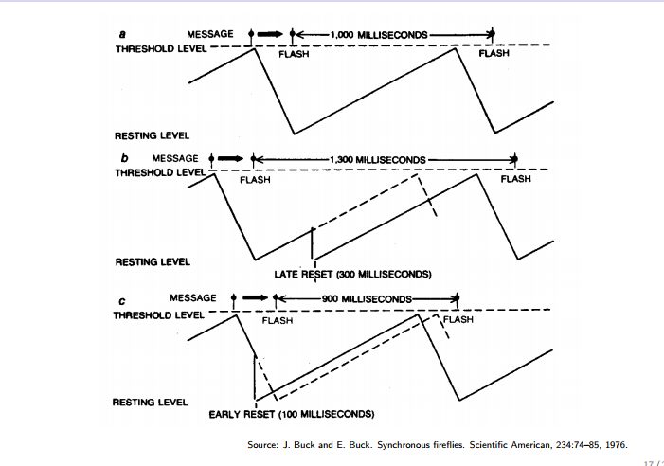

Picture 1: An illustration of fireflies’ clock mechanism inside the brain

## Species Diversity

The main difficulty in extracting firm results and a robust model to describe the biological function of synchronized flashing lays in the wide differences in the behavior among the species, even from the same genus. The male flash range of period is wide, form 0.5 up to 5 seconds as well as in contour; Pteroptyx cribellata and Luciola papilla flash once while Pt. malaccae and Pt. tener twice a time. Moreover, there are species, like Pt. malaccae, which reach perfect synchrony in contrary to other species, as Pt. Valida, that demonstrate just a loose coordination. Diversity also exists in entrainment limits; Pt. cribellata has a wide range compared to these of Pt. malaccae and L. papilla. Different behavior also appear in the conditions under which synchronization happens, Pt. malaccae demonstrates a sedentary synchronization, perched on trees and Pt. Cribellata as well as Luciola Pupilla synchronize in flight. Finally, there are species accepting only phase- advance pulses and other species that which entrain by both advance and delay phase pulses. (Buck, 1988)

## Types of Synchronization

Buck’s experiments showed that for some species the stimulus always advanced the fireflies rhythm (pulsatile coupling) while for others could be either delayed or advanced, depending on whether the firefly was just about to flash, whether it was halfway between flashes etc. This conclusion creates a need for a distinction of synchronization in 3 levels(Mirollo, Strogatz, Journal, & Dec, 2007,pp 1658):

1) Synchrony: This refers to oscillators firing together, that is for a group of fireflies to flash together. It should be noted that true synchrony never occurs in real populations due to the inevitable existence of distribution of natural frequencies.

2) Phase Locking: In this case the synchronization is of a “weaker” form as there is no demand for the oscillators to fire at the same time, as long as the phase different between them stays constant.

3) Frequency Locking: This is the loosest approach of synchronization, as only the same average frequency of the oscillators is required, with no necessity of fixed phase relationship among them.

Another way to distinguish 3 types of synchrony in systems like the group of fireflies, also derived from to Buck’s experiments in different species, is according to whether their phase accepts advances and/or delays.(Buck, Buck, Case, & Hanson, 1981):

1) Phase Advance Synchrony: This mechanism describes the oscillators which, given a pulse of light, can advance its phase but under any circumstances can experience delays. This type of synchronization is described by “integrate-and-fire” Mirollo and Strogatz model presented below and its representatives are the American firefly species Photinus Pyralis.

2) Phase Delay Synchrony: In this mechanism, oscillators phase either advances or delays, according to where the pulse of light arises. This type describes more complex models, in which insects’ frequencies may vary, as it happens to species P.cribellata. Moreover, each oscillator in this species has an intrinsic frequency that contrasts with the forcing frequency transmitted by the light pulses received. As a result, the oscillator experiences a unique phase shift, equal to the difference between the free-running period and the forcing period. The firefly entrains to a range of periodic stimuli within one or two impulses, but attains zero phase lag only when driven at his intrinsic frequency.

3) Perfect Synchrony: This type of synchronization describes the ability of an oscillator to entrain with zero phase lag. Besides seen in three Asian firefly species, P.malaccae, Pteroptyx tener and Luciolla papilla, perfect synchrony is extremely rare in nature, as the range of frequencies that lead an animal to synchronization is actually very small and once the forcing frequency is out of this range, the oscillator tends to be drifted along. In fact, there appear to be no models which will give zero phase difference for frequency ranges away from oscillator’s intrinsic one.(Ermentrout, 1991b) A model based on this mechanism, developed in an effort to describe P.malaccae’s entrainment is the Ermentrout model, discussed below.

# Coupled-Oscillators Synchronization

Coupled-oscillators are the key concept behind the phenomenon of collective synchronization, which is the spontaneous adaption in the same frequency of a huge number of oscillators that form a system. Remarkably enough, this adaption is unaffected by the inevitably different individual natural frequency of each oscillator. There is a wide range of biological and natural examples of such synchronized systems, from bird flying patterns, menstrual periods, heart’s pacemaker cells, crickets that chirp in unison, and microwave oscillators, finger tapping to fireflies flashing as it was previously stated.(Strogatz, 2012 pp. 11-40)

Even though collective synchronization appears to have a central role in nature and such phenomenon surrounded humanity since day one, it was not until 1958 when Wiener made the first attempt to study it mathematically. (Wiener, 1958). Wiener also speculated that it was involved in the generation of alpha rhythms in the brain. He tried to derive a mathematical formula from the phenomenon using Fourier integrals to approach it, an effort that turned in vain due to its complexity and the inability to incorporate the dynamic state of the problem.

A later approach by Winfree in 1967 set coupled-oscillators synchronization problem in new feet. Winfree proposed a huge population of interacting limit-cycle oscillators and recognized that simplifications can occur under the conditions of weak coupling and nearly identical oscillators. He also underlined that mutual synchronization is a form of cooperation. He made a firefly machine from 71 electrically-coupled neon oscillators with a narrow distribution of natural frequencies and by the experiments conducted he found that when oscillators were coupled equally to one another through a common resistor, synchronization never occurred.

Numerical stimulations did not prove his formulation of the phenomenon, but his work draw the attention of physician Yoshiki Kuramoto, who developed “Kuramoto Model”, a globally coupled model based on phases dynamics determined by neighbor average. Lacking stability as well as its undeniable disability to practically incorporate the dynamics based on neighborhoods it was not able to describe sufficiently enough the various biological and natural phenomena of synchronization, yet it still forms one of the most realistic biological models. (Steven H Strogatz, 2000) . Kuramoto’s Modela as well as Mirollo and Strogatz pulse-coupled oscillators and Ermetrout’s biologically focused approach, all of them based on fireflies’ flashing synchronization, will now be further discussed.

## Kuramoto Model (1975)

Driven by the phenomenon of collective synchronization in enormous systems in nature, and inspired by previous work of Winfree on huge populations of interacting limit-cycle oscillators, Kuramoto contributed in the field by constructing the first synchronization model of coupled oscillators that remained in history as the Kuramoto model.

However before moving on to Kuramoto’s model one must take into consideration the assumption he made. He used the perturbative method of averaging to show that for any system of weakly coupled, equally weighted, all-to-all, nearly identical, limit-cycle oscillators the long term dynamics can be prescribed by the following phase equations:

, i=1,2,…,N where,

* is the natural frequency of i-th oscillator,
* is its phase
* is the interaction function of oscillators i and j

Although the model is already simplified, another simplification was made regarding the coupling as purely sinusoidal:

, K≥0 being the coupling strength.

Also each of the frequencies is thought to be described by the same distribution g(ω), with g(ω) being unimodal and symmetric about its mean frequency Ω (ie. g(Ω+ω)=g(Ω-ω). Without loss of generalization, he implied Ω=0 (last figure)

So this leaves the governing equations:

,i=1,2,….,N

For the visualization of the model Kuramoto proposed a swarm of points (the oscillators) running around the unit cycle in the complex plane. The complex order parameter is

,

where r(t) measures the phase coherence, ψ(t) being the average phase.

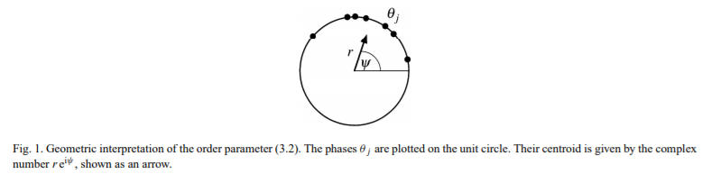

Picture 2Visualization of Kuramoto's model

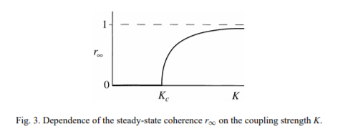For instance, if the oscillators are moving in a tight single clump, then r∼1, and the whole population acts like a giant oscillator. On the contrary if oscillators are scattered around the unit cycle, then r∼0, the oscillators are incoherent.

Picture Evolution of r

Because for the order parameter stands , equating the imaginary part yields , leading to the new form of governing equations

, i =1,2,…,N

In this form oscillators seem uncoupled from the others in the system, although they are interacting, not directly at this point but though the mean field quantities r and ψ, with each phase pulled to the mean frequency ψ, rather than toward to any individual oscillator. Moreover the coupling strength is proportional to the coherence r, as the population becomes more coherent, with more oscillators going into synchrony, r grows and so does the effective coupling Kr, recruiting more oscillators into synchrony. If the coherence increases further with these added new oscillators the process continues, otherwise it becomes self-limiting.

After this analysis, it is very interesting to understand how r(t) evolves. For fixed g(ω), as a density function with infinite tails (like a Gaussian) and variation in the coupling strength K, simulations proved that there is a threshold value , and when K is less, r(t) decays, and the incoherent state is stable. For values of K above , r(t) grows, reflecting instability in the incoherent state, and clusters of oscillators synchronizing. In the end r(t) saturates at some <1 level.

At a microscopic level of individual oscillators, Kuramoto found that two groups were formed. A partially synchronized state is formed with ‘locked’ and ‘drifting’ oscillators. The former refer to the oscillators locking at the mean frequency Ω and co-rotate with the average phase ψ(t). These are the oscillators that start the rotation at frequency near the center of the frequency distribution. The ‘drifting’ oscillators are the ones that have frequency near the tail of g(ω) and they run near their initial frequencies and drift relative to the synchronized cluster. Increases in K bring more oscillators in he locked cluster, leading to increase in as shown in the figure.

It was obvious that finding an exact value for was important and to find this value Kuramoto made even more assumptions. He sought steady solutions where r(t) is considered constant and ψ(t) rotated uniformly at frequency Ω. By letting r🡪 he found the critical coupling to be . (Steven H Strogatz, 2000)

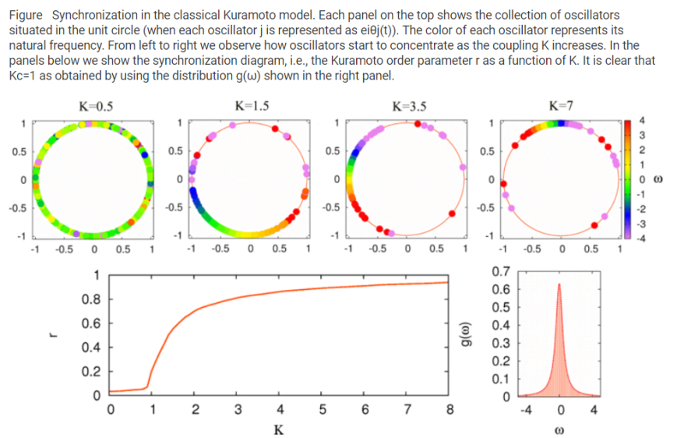

Picture 4 Sumarize of Kuramoto's dynamics(Hermoso De Mendoza, Pachón, Gómez-Gardeñes, & Zueco, 2014)

## Charlie S. Peskin (1975)

A special mention to Charlie Peskin and his work in *“Mathematical Aspects of Heart Psychology”* could not be discarded, as Peskin was the one that first posed the question of self-organization and collective synchronization is nothing but a form of it- as it raised from his observations on the behavior of pacemakers in heart cells. He imagined the pacemaker as a system of N “integrate-and-fire” oscillators. A voltagelike state variable was attributed to each one of the N oscillators, subjected to time depended dynamics[1], with dissipation factor. Let be the state variable of i-th oscillator, then  when it fires (in case of fireflies that is when the i-th firefly flashes) and  immediately jumps back to 0. Moreover, it is supposed that it satisfies: , S a constant and γ the dissipation factor.

The interaction model between the N oscillators is a simple pulse coupling: when an oscillator fires, all the other oscillators in the system are pulled up by ε or pulled right to firing state, whichever is closer. Mathematically formed that interaction rule is:



Peskin managed to prove for N=2 and small ε and γ, where γ is the dissipation constant of state variable dynamics, that “for any arbitrary conditions, the system approaches a state in which the oscillators

## Mirollo and Strogatz (1990)

It was Peskin’s early work that inspired Mirollo and Strogatz to work together, generalize and analyze the above model and also prove Peskin’s hypothesis for all N and for all ε,γ > 0. Their main idea is “In between firings, use Peskin’s formula to advance all the oscillators towards their thresholds”. The following section, based on their common work on Pulse-Coupled Biological Oscillators (Mirollo et al., 2007) presents an outline of their proof, the model they created for N oscillators and a discussion on its the drawbacks and why it is an unrealistic model for biological systems such as fireflies, after all.

### Outline of the Poof

1) Consider and list all possible configurations, that is, initial conditions of the system. Note that N oscillators require N-1 dimensional hypercube in order to account all possibilities.

2) Translate system’s dynamics in a pictorial framework, by plotting Phase Respond Curve (PRC)[2] of the system. The goal is to predict whether the system will synchronize given all possible initial conditions. In pictorial framework that can be simply explained as given all the possible dots in the PRC, each dot representing an oscillator in its initial phase.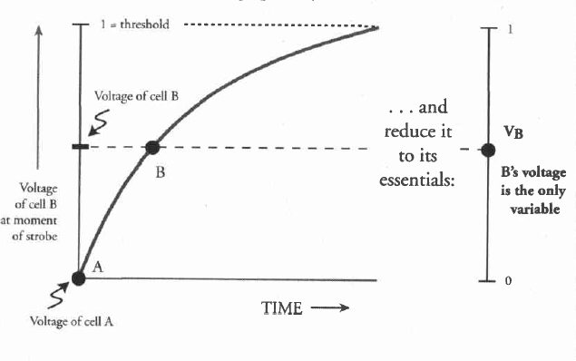

Picture 5 An example of the pictorial framework, the PRC of a 2 oscillator system

3) Consider bad and good points. Bad points are the initial conditions which not lead to synchronization, where good points stand for the obvious. Bad points do exist, but they are proven to be so few and spare that they occupy a zero area.

4) Focus on Terrible points, that is the worst of Bad ones and work with them only. Prove topologically that they occupy zero area and the proof is done.

Note: As it will be further discussed and explained above, it is of great importance that PRC will be bowed down and not linear as Buck imagined it. Otherwise it is shown that if voltage accelerates up to threshold stimulations indicate no necessity for synchronization. The oscillators can get stuck in a random pattern of firing.(S H Strogatz, 2012, pp 29)

### Model of N Pulse-Coupling Oscillators

Pulse-coupled oscillators define a system that oscillates periodically in time and interacts each time an oscillation is completed. The general idea is that a group tends to grow by “absorbing” other oscillators, thus reducing the number of groups in the system until only one group remains and therefore synchronization of the group is achieved.

##### State Space and State Variable

Instead of Peskin’s voltagelike state function for the ith oscillator, here  is assumed, where:

*  , the phase variable, has the following properties:

i) , T : the cycle period

ii) just fired so f(0)=0

iii)  fire so f(1)=1

* is smooth, monotonic increasing (f’>0) and concave down (f’’<0)
* Since f is monotonic, g is defined as, so that  and g is also smooth, monotonic increasing (g’>0) and concave up (g’’>0).

The system is studied after one oscillator had just fired and x returned to zero (so did φ). The state of the system S is characterized by all φ, for all n<N independed oscillator or group:



Note: There are two conventions standing, that the connections of the system are all-to-all and that all oscillators have identical dynamics, enduring that the flow will be preserved in cyclic ordering. Moreover, another convention is that all oscillators have the same frequency. That in addition to f being monotonic ensure the order is maintained after each firing: The oscillators fire in reverse order to their phases: after oscillator n fires, it is relabeled to 0 and n-1 relabeled to n and fires next and so on.

##### Firing Map

The firing map  transforms to a phase vector right after the next firing, which happens after. During the time of the next firing, ith oscillator’s new phase is. Based on these, let’s define:

* , giving the phases **right before** the firing: 
* , giving the phases **right after** the firing:



Therefore, we can now describe the firing map , where S is the domain of h.

##### Absorptions

As briefly mentioned above, the main idea of this model is based on the concept of absorptions. Absorption happens when the fire of one oscillator causes the other one to fire immediately, as it is closer to reach threshold so it jumps straight to 1, thereby from so on the two oscillators share the shame φ and act as one. Mathematically speaking this is simply described in the sense of our model as:, ε being the dissipation factor. In such a case, the following apply to the system:

1) The domain of h is not S but. If  an absorption occurs after a firing of strength ε.

2) As groups are created, the strength of the group’s pulse is now calculated as the sum of its oscillator’s strengths, under the thought of a group being a single oscillator with enhanced strength. Different strength will now apply in the system, causing however no difficulty or malfunction of the model’s behavior.

Mirollo and Strogatz proved that this model will achieve synchronization under any initial circumstances, as absorption after the absorption the system will end up forming one large synchronized group. It is also proved that there is a repelling fixed point, as ε approaches zero, 

### A simplified version of Mirollo and Strogatz model

Each pulse-couple oscillators of the system is described by a phase- function φ(t), encoding the remaining time till next firing. φ(t) evolves linearly until it reaches a threshold value normalized to 1, let’s say φ*, then fires=flashes, simultaneously sends a pulse to its neighbors and finally resets its phase.

The interaction between system’s oscillators takes the form of a pulse perceived by its neighbors. If not coupled to any other, an oscillator will oscillate and fire with a stable period T. When coupled, an oscillator is a receptor of neighbor pulses, and the reception of such a pulse will instantly increase its phase by an amount based on its current value (therefore determined by PRC): , causing it to fire earlier.

In Mirollo’s and Strogatz’s simplified model it is:

, with and ,

obviously b being the dissipation factor and ε the amplitude increment. All the above statements stand in the simplified model, that is for all b, ε>0 and N number of oscillators synchronization will be achieved, thus the system will converge, in time inversely proportional to b*ε. Moreover, the synchronization relies on the instance of the arrival of a pulse, no interference is observed and two pulses emitted simultaneously can superimpose constructively.(Tyrrell, Auer, & Bettstetter, 2006)

### Model’s discussion

Mirollo and Strogatz proof of conjecture stands for all initial conditions, infinite number of oscillators and it is believed (yet not proved) to work for all kinds of interactions within the system. However, one can easily understand that the foundations the model lays in are unrealistic and far from a real biological model, especially one of the fireflies.

First, in order to achieve simplicity it is assumed that all oscillators have the same frequency, fact that doesn’t stand in reality. It is a fact of great importance for the model, as if there are no similar frequencies the simple indexing scheme of frequencies would fail as one oscillator could overpass the other in each iteration and analyzing the dynamics would be more complicated.

Furthermore, there is assumed to be a global connection in the system, that is an all-to-all pulsing reception model. This convention is necessary for the simplicity and linearity of the model, yet it is biologically utopian as it is proven that fireflies have limited radius of pulses’ reception.

This model is based on the idea of the faster one setting the pace and nonnegative interactions (delays) occurring in the system. Although this stands for a lot of occasions in nature, as stated above this is not a basic rule for all fireflies species, some submit to it other are not.

Moreover, another serious convention is that no chain reactions are allowed. That means if the pulse of oscillator A move B to the threshold, B is not allowed to fire until the next time it reached threshold (that is one fire missing). This happens because if B fired immediately, he would cause a new pulse that should be calculated to the system, additionally to the pulse of A. However, in nature that is exactly what happens.

Finally, the last convention comes to how group pulses are calculated: as the sum of the individual pulse strengths. Although the assumption is not necessary for the proof of the main theorem, however biologically it is improbable that a group of 13 fireflies flashing simultaneously will have 13 times the effect the one would. Improbable yet not proved.

## B. Ermentrout (1991)

Inspired by the perfect synchrony mechanism of P.malaccae, the model of a system based on the insect’s PRC is proposed, but in this system the frequency of the oscillator is allowed to slowly adapt, that is to modify its intrinsic frequency, so that zero lag phase entrainment will be achieved. The idea is that eventually the phase shift between stimulus and oscillator becomes fixed and its size remains small as the limits of entrainment are reached. The following section, based entirely on Ermentrout’s work (Ermentrout, 1991a) will present and discuss his model.

### Adaptive Frequency Model for Collective Behavior

Let us consider the phenomenon of fireflies’ synchronization while sitting in a tree, the “firefly tree” as usually mentioned. Let us also specifically focus on P. malaccae species that achieves perfect synchronization. In order to develop a model that bears the highest resemblance possibly to the biological aspects of the phenomenon, the main idea is that each insect has an intrinsic frequency, unique for each insect, yet there is a range of frequencies that enable synchrony same for all of them, let’s say, and let’s describe the form of the j-th periodically forced oscillator, a firefly on the tree, as:

, a time-depended variable frequency and

, where

* the intrinsic frequency of j-th oscillator,
* is the phase of the oscillator after the stimulus,
* ε is the rate at which the oscillator returns to its previous frequency,
* the strength of the pulse from k-th oscillator observed by j-th oscillator,
* G measures the effect of the pulse on the intrinsic frequency, representing the PRC. It is proven that G can be no independent of ω in order for the model to be adaptive.

All the functions are periodic with period 1. The model obeys to the basic idea of frequency adaption, that is:

i) , when no stimulus is applied

ii)  if the pulse comes early in j-th oscillator’s cycle

iii)  if the pulse comes late in j-th oscillator’s cycle

Which is translated into “The final frequency is not the same as the intrinsic frequency of any oscillator: the faster insect slows down and the slowest speeds up”.

##### PRC

With respect to P.malaccae’s PRC as formed after years of experiments, and in order to submit to model’s main idea of frequency adaption, PRC is formed as:

, where:

* 
*  is the phase after the stimulus
* periodic functions with the following properties:

i) 

ii)  and φ: the phase shift in the cycle

iii) and 

And an ideal choice for these functions should satisfy the following model’s behavior: For each oscillator of the system, if: the frequency between n-th and (n+1)-th impulses; τ: the forcing period;  the phase after n-th stimulus, then “1:1 locking is achieved ⬄ ⬄ ⬄ and φ satisfies: . Similar results stand for ”

At this point it starts to become clear that by choosing appropriately, synchronization with zero phase lag in a model that supports large differences in frequencies can be reached. In further analysis of this model it is proved that locking can occur for, ; .

#### A simplified version of Ermetrout’s Model

Due to this model’s increased complexity, its behavior and some characteristics are not as straightforward as in Mirollo and Strogatz. In order to gain some inside, let us consider a simplified version that loses no unaffordable amount of information, yet is easier to handle. Let

, where

.



This latter form says that the insect responds to all nearby insects in precisely the same way and their response does not vary once the nearby oscillator exceeds the range Smax.

For ε sufficiently small, it is proved that the phase shift between oscillators is O(ε) and all oscillators tend to a locked frequency, Ω.

Assuming that =0, that is no change occurs to the intrinsic frequencies if oscillators are in phase, and letting , then model of N oscillators comes to its lowest order in ε if . This is a set of N linear equations and N+1 unknowns, Ω and . Taking under consideration that  is a solution for every constant C, and if only all to all coupling is concerned, a good approximation is =α/N, a constant, and .

Recalling the definition of, the result is that all oscillators synchronize to a frequency which is the mean of all the individual oscillators and the phase difference is of order ε, Ο(ε).

### Model’s Discussion

Ermetrout’s model comes closer to a realistic biological system as it evolves in order to allow from synchrony to stimuli closer to the native frequencies of system’s oscillators. This becomes possible thanks to the alteration of the notion of PRC that the mechanism includes.

However, in order to be able to solve the synchrony equation that form the model, some assumption should be made: The maximum and minimum frequencies are the same for all oscillators; it is the intrinsic frequency of each that is different. Moreover, the coupling is, as Mirollo and Strogatz model all-in-all and the notion of neighborhoods is not taken into account. Under these assumptions it is proven that synchronization occurs, within order ε, as long as the intrinsic frequencies lie within the range of entrainable frequencies.

If seen in a different context, the equations that describe this mechanism bear great resemblance to those used for the description of an interconnected neural network and indeed it was shown previously that each firefly is controlled by an endogenous neural oscillator, a pacemaker. Thus the procedure presented above represents a form of learning, learning how to synchronize. Moreover, fireflies’ neural oscillators interact neurally through the visual system (flash). The only significant difference between the firefly system and an oscillatory neural network is in the time scale (milliseconds /seconds) and the space scale (microns /meters).

# Synchronization in Small-Words

A general description of a small-world network is the type of network in which most nodes are not neighbors of one another, but the neighbors of any given node are likely to be neighbors of each other and most nodes can be reached from every other node by a small number of hops or steps. Specifically, it is defined to be a network where the typical distance L between two randomly chosen nodes grows proportionally to the logarithm of the number of nodes N in the network, while the clustering coefficient is not small. This is a really important characteristic as, until small world networks were discovered, distance and clustering used to be considered as proportional.

One can gain a deeper understanding in small-world networks if contemplate Strogatz ’s concrete example of creating one(S H Strogatz, 2012, pp 238). Let an extremely ordered network of 6 billion nodes, with no respect to what they represent, arranged in a circle, each node connected to 1.000 neighbors, 500 on each side (left and right). We will smoothly transform this ordered, symmetric ring lattice in a random one, by rewiring (pick some of the original connections and erase them, then create equal number of random connections) its links, that is choose a fraction P between 0 and 1 and for any desired amount of rewiring and tune the network form 0, representing its current state, to 1 standing for complete randomness. In the between the network would be a blend of these two states. As slowly turning from 0, it will begin to morph; a few links will break and redistribute themselves haphazardly. As the procedure continuous, more and more random connections will be established, transforming the symmetry of the ring, yet leaving part of its structure intact.

This evolving architecture is measure by two statistics; “Average path length” and “Clustering”. The average path quantifies the degree of separation, by calculating all shortest paths (number of nodes) between every two nodes on the network and then finds the average of all formed shortest paths. It is a measure that reflects the global structure of the network, depending on the connections in the entire network and measures how big the network is. Clustering on the other hand is a local measure that takes into account the connectivity within neighborhoods. It quantifies the average overlap in the network by calculating the probability two nodes linked to a common third node also be linked to each other, measuring how incestuous the network is.

Have gained some inside on small world networks and their unique characteristics, the first question that arises is why it is relevant to synchronization problem and whether fireflies’ group flashing could be modeled as a small world network- and if so what will be the gain. Suppose a network of biological oscillators, fireflies in our case, where everyone is connected a few insects apart. Does this connection affect how the group synchronizes and, would small distance and big clustering architecture inside the network lead to a faster and easier synchronization due to its tight links? Watts and Strogatz stimulations showed it did!(Watts & Strogatz, 1998)

As stimulations provided encouraging results, let’s try to transform fireflies’ system in a small world network and look for a synchronization model from that angle. Each firefly in the network represents a self sustained oscillator and links stand for the pattern of interactions. A simple model based on oscillators’ phases with distributed frequencies is the Kuramoto model, assuming mutually coupled oscillators by an attractive sine-wave interaction. Instead of all to all connectivity though, the architecture of all the previous models discussed, let the structure be a ring, that is oscillators arranged in a circle, each coupled to a fixed number of neighbors on either side. Up to this point it is proved that this system cannot achieve global synchrony under almost no circumstances, unless the oscillators are identical .On the contrary, it tends form neighborhoods, clusters of oscillators synchronized together but not in a global frequency and phase. To overcome this problem, the ring lattice is morphed toward a random net, by the rewiring procedure described above. Stimulations in this specific case showed that such conversion of less than 2% of systems connections caused a dramatic change to its dynamics. The oscillators spontaneously drifted to global entrainment by locking their rhythms to a single compromise frequency. The small-world architecture apparently fostered global coordination more efficiently.

Besides’ Watt and Strogatz, Watt and Chen in 2002 also investigated synchronization in a network of continuous-time dynamical systems with small world connections. They showed that, starting from a dynamic system with Nearest Neighbor coupling and transforming it to a small world network, following the procedure presented above, synchronization occurred independently of the coupling strength and for small P, even when to original network failed to synchronize. That indicated that the addition of small fraction of new connections in a NN coupled network can enhance its entrainment significantly.(WANG & CHEN, 2002)

Another research was conducted by Hong, Choi and Kim in 2001, to investigate collective synchronization in a system of coupled oscillators on small-world networks. They were expecting a faster or even stronger synchronization by making variations in the rewiring probability and the coupling strength. They first constructed a regular network on N nodes with only local connections and they turned it into a small world network by rewiring, with rewiring probability P, ending with a network of NPk shortcuts. At each node of that network was located an oscillator and a link between two nodes represented coupling. They found the governing equations of motion of the system of N oscillators to be: , where,

* is the phase of oscillator i
* K is the coupling strength, normalized with respect to the average connections per node (2k)
* is the set of nodes connected to node i
* the intrinsic frequency of i_th oscillator and every is following the same distribution of frequencies g(ω)

They used the Gaussian distribution N(0,1) for , k=3 for the network, regardless of N ( up to N=3200), discrete time step Δt=0.05 and time steps to integrate numerically the previous equation. For each network they constructed they performed 100 independent runs with different configuration of the intrinsic frequencies as well as different network realizations, over which averages were taken. They found the following order parameters where <…> denotes averages over time and […] averages over different realizations of the intrinsic frequency.

m=[<|, for the phase, and

for the frequency. Lastly, two oscillators were considered synchronized if the difference in frequency was smaller than .

The following figures contain the results they got, displaying the phase and frequency order parameters ( m and q) versus coupling strength K. For K ->0 there is no synchronization, while for K->∞, all phases of the oscillators become synchronized, regardless the structure of the network.

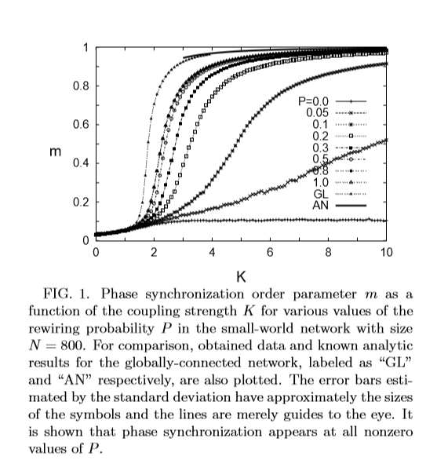

Picture Phase and frequency synchronization

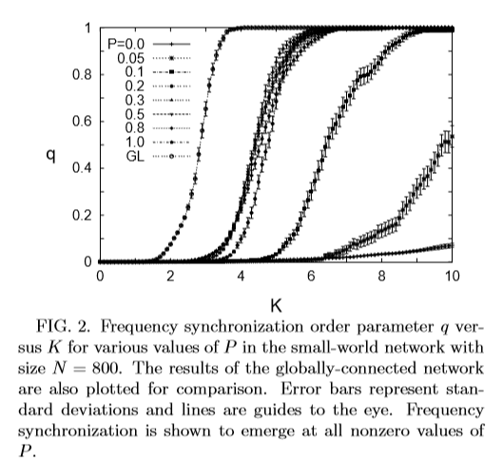

The most interesting result was that both synchronization of phase and frequency exhibit strong dependence on the rewiring probability P. While there is no synchronization happening in the original network (no shortcuts, P=0), with only a tiny fraction of shortcuts (P=0.05) there could be achieved synchrony. Also both m(K) and q(K) saturated and didn’t show any significant difference for values of P>. Thus only with half the shortcuts synchronization is achieved in the same pattern as it would in a random network (P=1). So, a globally connected behavior can be established with a lower cost of complexity.(Hong, Choi, & Beom Jun Kim, 2008)

Also, a study in 2003, regarding synchronization of oscillator networks with small-world interaction and coupling delays, as delays can be viewed as arising from the finite speed of transmission and spreading as well as congestion, showed that when the network comes into synchronization then the synchronized state is stable and independent of the topology of the network. They proved that both theoretically and numerically with simulation in matlab. The main difference here , is that they didn’t use the usual Watts and Strogatz rewiring algorithm, but the Newman-Watts algorithm, in order not to encounter the problem of unconnected clusters. With this algorithm there is no breaking of connections between two nearest neighbors and a connection between two unconnected vertices is added with probability P. (ie with p=0 the original network stays intact, and for p=1 a fully connected network appears, instead of the random we would get with the Watt-Strogatz algorithm). They found the following governing equations of motion: where,

* is the phase of oscillator i,
* ω is its natural frequency,
* c is the coupling strength, same between all oscillators,
* is the number of signals the oscillator i receives = the degree of node i,
* f is the coupling function,
* τ>0 is the time delay,
* N the total number of oscillators,
* the normalization factor, meaning that each oscillator i is influenced equally by all oscillators that send signals to it and,
* A= the adjacency matrix that encodes the connection topology of the network.

For the synchronized state they found that , and this collective frequency is obtained when Ω=ω+cf(-Ωt). They added small perturbations to determine the local stability of the solution and used linear algebra to solve the equations that arise. They ended up with a proof that contemplated their numerical results proving that the synchronized solution is stable when cf’(-Ωt)>0 and the synchronized states of the phases stay stable under various topologies and for different probabilities. (Li, Xu, Liao, & Yu, 2004)

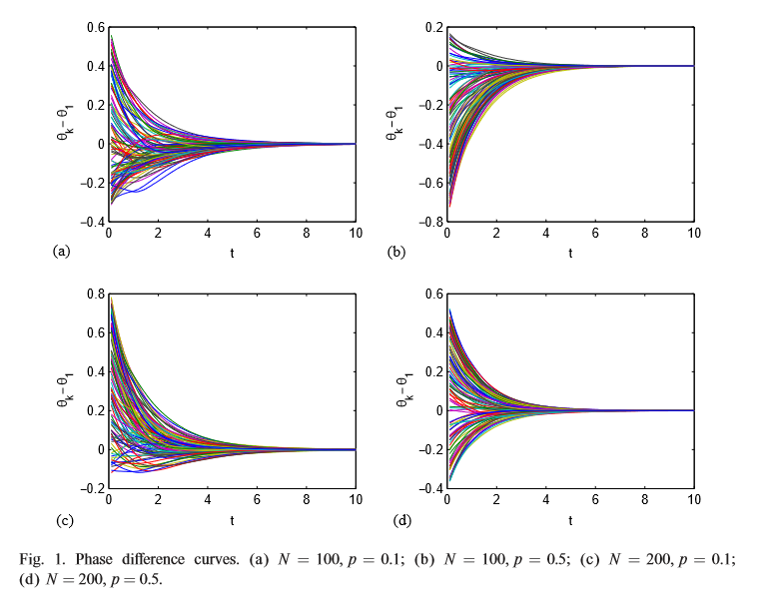

Picture Synchronization with phase delay

Finally, in a 2015 study that included an investigation of synchronization in systems of fireflies, modeled as dynamic models under the theory of complex systems and in different topologies (Nearest Neighbor coupling, Star Coupling and Small-world coupling). They considered each node as a 2-dimentional discrete time map and they used the following state equations:

,i=1,2,…,N where ,

* , the state variables of node i
* ,i=1,..,N,
* c>0 a constant representing coupling strength of the complex network,
* Γϵ the adjacency matrix,
* A= the coupling matrix constructed as follows

,

Where =degree of node i

Finally, the network is said to achieve synchronization when

They used a simple dynamical model

x(k+1)=sin(w(k)t(k))

t(k+1)=t(k)+ with

* x(k) a simple representation of a firefly in discrete time
* w(k)=2πf the angular frequency and f the “blink” frequency,
* t(k) the sampling time and k the number of iterations.

They used these equations in the three mentioned topologies in networks with N=5 nodes.

The results are based on Matlab simulations for 5 nodes networks shown in the following graphs. Below there is the connection topology of each system and the temporal dynamics of as well as the errors for the nearest-neighbor topology.

On the left uncoupled while on the right coupled. The results of other topologies are similar to the graphs on the right. The only difference was that for the small world topology, the c value needed for synchronization was slightly smaller than all other cases. (Arellano-Delgado, Cruz-Hernández, López Gutiérrez, & Posadas-Castillo, 2015)

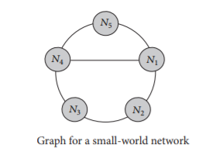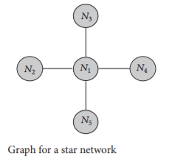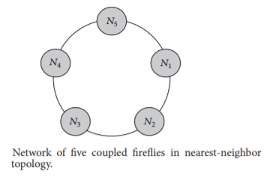

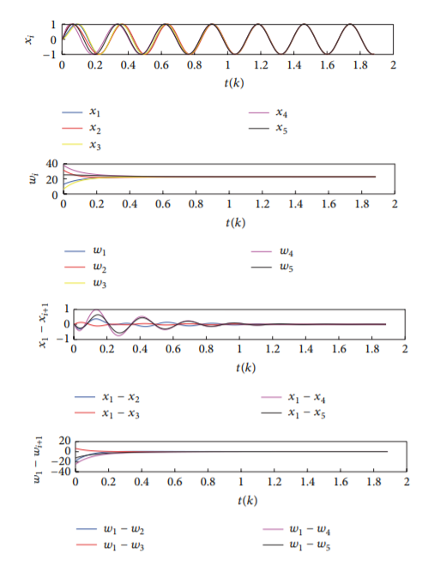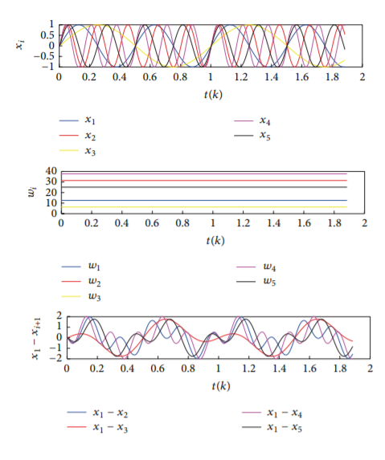

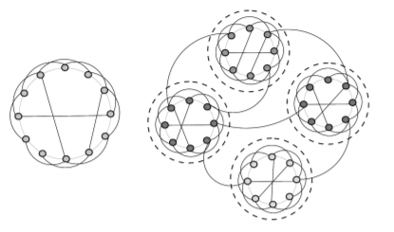In 2009 researchers in China generated a small world network with community structure and by use of the Kuramoto model, they investigated the phase synchronization of this network. A question that arises is why to create such a network and the answer is that such networks can be found not only in biological systems but also society, internet and more.

Picture 8 Small world network with comunity structure

They started with a simple network of m isolated ring lattices with nodes in which every node is connected to its first 2z neighbors (z on either side) and there are no connections between lattices. Each ring lattice can be regarded as a community. They used two probabilities P1 for new connections between nodes belong to the same community and P2 for those belonging in different ones. Thus the ratio r= is a parameter defining the ration of inter to intra-connectivity, with smaller r values corresponding to sparser external edges thus stronger community structure. They investigated the degree distribution, clustering coefficient and modularity and found that the network would exhibit both SW and community structure. Also by the following measure they investigated communication coefficient, measuring the efficiency of exchanges over the network , with the geodesic between nodes I and j so that the communication efficiency, which characterizes the small world can be shown as a function of parameter r, with the property of SW increasing E, with just a fraction of a few random connections. They found that the SW property appeared for intermediate values of r, the result was increasing E(r), but Q(r) and C(r) remaining almost constant at their original values and the network would exhibit both SW and community structure.

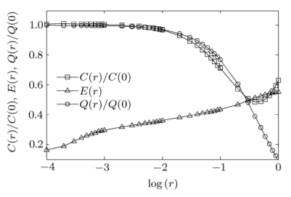To conclude, they used the coupled phase oscillators of Kuramoto model, to analyze the dynamical behavior in the aforementioned network. The equations of motion of the dynamics of N oscillator system (i-=1,…,N) are:

Picture 9 Evolution of the dynamic behavior of the model

* the phase variable of oscillator i
* its intrinsic frequency
* the coupling strength
* the adjacency matrix

Where, uniformly distributed in the intervals [0,2π) and [-0.5, 0.5] respectively. They also used the order parameter M={| to measure synchronized states.

The oscillators are uncoupled for c=0 and they approach 1 for synchronized states. They used a network of 3 communities (A,B,C), N=1500 nodes, z=30 and p1=0.1 for every different value of r, M would increase in c for smaller r, ie stronger community structure greater coupling strength was needed. For r=0 they found that M for the network should be ∼0.667 and that there is also an abnormal area for r<0.001 in which the network would have even worse synchronization than the isolated communities even with a very strong coupling strength. On the contrary input signals contained by these edges disturbed the synchronization process of these communities when the order parameter of ith community only for r=0.1 the synchronization of the network would be near the same c and as fast on the synchronization of each community and for r<0.001 no synchrony was achieved.(Zhou, Zhao, Chen, Yan, & Wang, 2007)

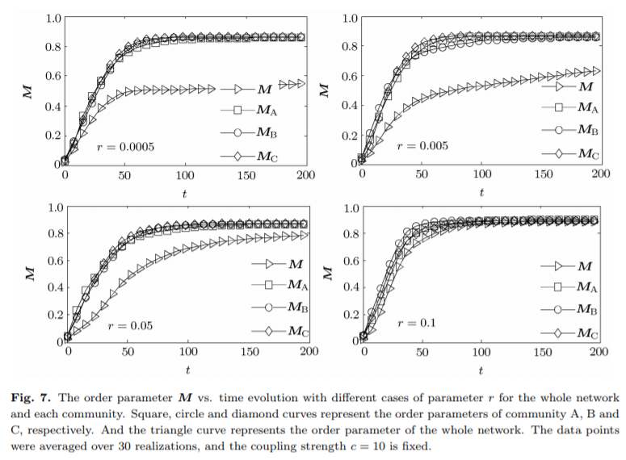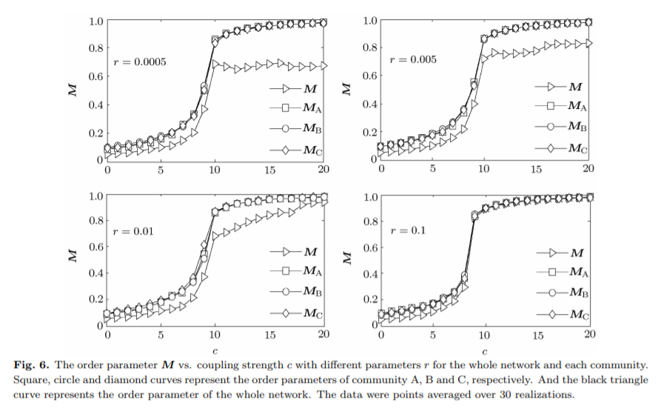

However, all indications so far that small world property enhances synchronization in a network are based on stimulation experiments and there is no solid mathematical proof so far connection explicitly the addition of random shortcuts to the synchronization of networks of coupled dynamical systems. Barahona and Pecora in 2002 made an extensive investigation in that connection by quantifying the dynamical implications of the small-world phenomenon, considering the generic synchronization of oscillator networks of arbitrary topology. Based on a generic formulation proposed by Pecora which enabled them not to include a particular amount or factor when calculating the connectivity content, they indentified synchronization threshold with an algebraic property of the Laplacian matrix of the graph. They then provided numerical and analytical quantification of how the small world scheme improved synchronization, when compared to standard deterministic graphs and even to fully random ones. However, the concluded that there is no guarantee that the small-world property will endure networks synchronization. That is because the synchronization threshold lies within the boundaries, but is linked to the end of the small-world region and not its onset.( Barahona, & Pecora, 2002)

# Implementation

We simulated several coupled-oscillator models that ended up to synchronize in Python, using several architectures, initial conditions as well as adaption rules, and visualized them in order to confirm some basic rules.

### 1st Model

Fireflies (oscillators) were placed in a straight line and a k nearest neighbor coupling. They all start in a non firing state and a random value φ, within a preselected range, is distributed in each one of them, corresponding to the time they remain dark.

Synchronization rule is defined as: In the end of each iteration (that is one flash occurs) each firefly adapts to the frequency of its slowest neighbor, itself included. That is, a model that adapts to the fastest firefly’s rhythm. Flashing happened at tk moment, and the oscillators is back to zero again in tk+1 moment.

Therefore, the first state of synchronization process happens from the begging till the flash of the last one (slower one, with higher φ). Consequently, the n-th state of our process begins from the time after the flashing of the (n-1)th state slowest firefly, till the flashing of the slowest firefly in the n-th period.

User chooses, besides the range of initial phases, the number of fireflies in the model as well as the number k of nearest neighbors.

We also implemented this model in flying fireflies, that is a permutation in the vector’s (line’s) elements before each state of our process. Synchronization in this model happened much faster, that is less steps.



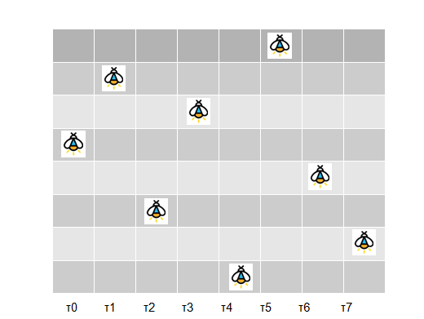

### 2nd Model

In our second model the adaption rule remained the same as in the first one, but the fireflies were placed in a matrix instead of a line, in order to simulate a swarm’s behavior.

Each oscillator is coupled with its k nearest neighbors, taking special consideration for the sides and corners of the matrix.

The visualization of the model presents different plots, where the flashing fireflies (attributed with the value 1) are presented in yellow color and the others (attributed with 0) in black. Each plots stands for a time moment, and time is condensed to enable an enhanced visualization. Thereby, the goal is a total yellow plot window to express model’s synchronization.

In a second trial there was also movement added to the model, in the sense of fireflies flying in a swarm. This was represented by randomly change oscillator’s position in the matrix in every step. This resulted to an impressive reduction in the number of required steps of synchronization.

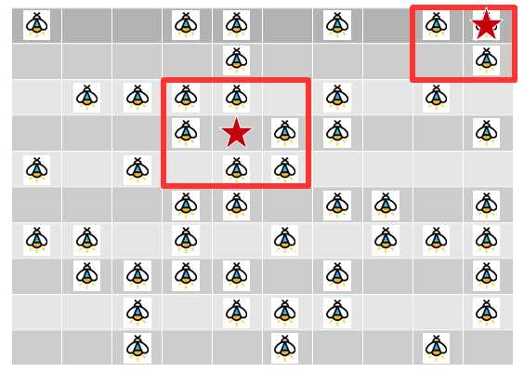

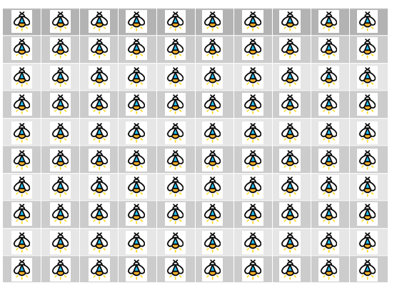

### 3rd Model

` In this model N fireflies are also placed in a matrix and k nearest neighbor coupling is applied. The difference comes to the adaption rule; each oscillator in each step of synchronization adapts to rounded mean frequency of its neighbors, itself included. In this model phase locking synchronization is achieved instead of perfect synchronization.

If we apply random movement in this model a global perfect synchronization is achieved. Movement in the model leads to a reduction in the number of steps required for synchronization. User chooses, besides the range of initial phases, the number of fireflies in the model as well as the number k of nearest neighbors.

### 4rth Model

In this model N fireflies are also placed in a matrix and k nearest neighbor coupling is applied. The difference comes to the adaption rule; the Mirollo and Strogatz model is partially stimulated; each oscillators receives a pulse ε=0.1*φ, from its fastest neighbor.

For groups of fireflies firing in unison in the fastest pace, the sum of their pulses is considered as the pulse of the group. The update rule therefore is: φ’ = φ – no of fastest neighbors* 0.1 *φ, setting a threshold to avoid overtaking. Perfect synchronization is reached under the convention that φmax - φmin  < 0.5 is considered insignificant.

### Comparison

When all models set in a range of (100,300) for initial conditions and k=1 for k-nn coupling, the resulting synchronizations the model achieved are given in the matrix below:

|  |  |  |
| --- | --- | --- |
| Model | N fireflies | Steps |
| 2nd no movement | 100 | 7*Increases exp proportional to N |
| 2nd with movement | 100 | 3*Non sign increase proportional to N |
| 3rd no movement | 100 | 24**Phase Synchronization |
| 3rd with movement | 100 | 7*Global perfect synchronization |
| 4rth, k-nn coupling, ε=0.01 | 100 | 34*Sync starts from the central node |
| 4rth,all-to-all coupling, ε=0.001 | 100 | 14*Uniform sync |

# Bibliography

Arellano-Delgado, A., Cruz-Hernández, C., López Gutiérrez, R. M., & Posadas-Castillo, C. (2015). Outer Synchronization of Simple Firefly Discrete Models in Coupled Networks. *Mathematical Problems in Engineering*, *2015*. http://doi.org/10.1155/2015/895379

Barahona, M., Barahona, M., & Pecora, L. M. (2002). Synchronization in small-world systems. *Physical Review Letters*, *89*(5), 054101/1-054101/4. http://doi.org/10.1103/PhysRevLett.89.054101

Buck, J. (1988). Synchronous rhythmic flashing of fireflies. II. *Quarterly Review of Biology*, *63*(3), 265–289. http://doi.org/10.1086/415929

Buck, J., & Buck, E. (1966). Biology of synchronous flashing of fireflies. *Nature*, *211*(5049), 562–564. http://doi.org/10.1038/211562a0

Buck, J., Buck, E., Case, J. F., & Hanson, F. E. (1981). Control of flashing in fireflies - V. Pacemaker synchronization in Pteroptyx cribellata. *Journal of Comparative Physiology □ A*, *144*(3), 287–298. http://doi.org/10.1007/BF00612560

Ermentrout, B. (1991a). An adaptive model for synchrony in the firefly Pteroptyx malaccae. *Journal of Mathematical Biology*, *29*(6), 571–585. http://doi.org/10.1007/BF00164052

Ermentrout, B. (1991b). Pteroptyx malaccae, 571–585.

Hermoso De Mendoza, I., Pachón, L. A., Gómez-Gardeñes, J., & Zueco, D. (2014). Synchronization in a semiclassical Kuramoto model. *Physical Review E - Statistical, Nonlinear, and Soft Matter Physics*, *90*(5). http://doi.org/10.1103/PhysRevE.90.052904

Hong, H., Choi, M. Y., & Beom Jun Kim. (2008). Synchronization in small-world networks. *Chaos*, *18*(3). http://doi.org/10.1063/1.2939136

John, & Buck, E. (1976). Synchronous Fireflies. *Scientific American*, *234*(5), 74–85. http://doi.org/10.1038/scientificamerican0576-74

Li, C., Xu, H., Liao, X., & Yu, J. (2004). Synchronization in small-world oscillator networks with coupling delays. *Physica A: Statistical Mechanics and Its Applications*, *335*(3–4), 359–364. http://doi.org/10.1016/j.physa.2003.12.037

Mirollo, R. E., Strogatz, S. H., Journal, S., & Dec, N. (2007). Synchronization of Pulse-Coupled Biological Oscillators, *50*(6), 1645–1662.

Strogatz, S. H. (2000). From Kuramoto to Crawford : exploring the onset of synchronization in populations of coupled oscillators, *143*, 1–20.

Strogatz, S. H. (2012). *Sync: How Order Emerges from Chaos In the Universe, Nature, and Daily Life*. Hachette Books. Retrieved from https://books.google.gr/books?id=ZQeZAAAAQBAJ

Tyrrell, A., Auer, G., & Bettstetter, C. (2006). Firefly Synchronization in Ad Hoc Networks.

WANG, X. F., & CHEN, G. (2002). Synchronization in Small-World Dynamical Networks. *International Journal of Bifurcation and Chaos*, *12*(1), 187–192. http://doi.org/10.1142/S0218127402004292

Watts, D. J. J., & Strogatz, S. H. H. (1998). Collective dynamics of “small-world” networks. *Nature*, *393*(6684), 440–442. http://doi.org/10.1038/30918

Zhou, T., Zhao, M., Chen, G., Yan, G., & Wang, B.-H. (2007). Phase synchronization on scale-free networks with community structure. *Physics Letters A*, *368*(6), 431–434. http://doi.org/10.1016/j.physleta.2007.04.083

Hanson F.E. (1982). *Pacemaker control of rhythmic fireflies* . In: Carpenter, D. (ed.) Cellular Pacemakers Vol.2 ,pp 81-100, New York

|  |
| --- |
| Norbert Wiener (1958). *Nonlinear Problems in Random Theory*, pp. 142. ISBN 0-262-73012-X. Cambridge, Massachusetts, USA: The MIT Press |
|  |

1. Dynamics: The evolution of the system in time
2. The curve of the voltaglike state xi for all oscillators and their phases